Neural Network Modeling

The neural network designed for this project is intended to predict whether or not an application will be chosen for funding through the Alphabet Soup Foundation. The foundation takes in application information including financials as well as use case for the project. It is necessary to build this network to process all 34,000+ applications for Alphabet Soup.

The target for the model is the column IS_SUCCESSFUL, which is the very last column in the original file. The features that are used in the model are the following:

* Application Type
* Affiliation
* Classification
* Use Case
* Organization
* Status
* Income Amt
* Special Considerations
* Ask Amt

There were two columns that were unnecessary to the model, which were the EIN and the Name of the organization. These were extraneous to the model, as they provide no benefit to the neural network and would be interpreted as noise.

I chose to use two layers in my model, with 50 neurons in the first and 25 neurons in the second, with one output neuron. This was a decision made because of the high number of inputs. Initially, I was testing with far fewer numbers of neurons in my two layers, but after increasing the number, I was successful at achieving a high rate of accuracy.

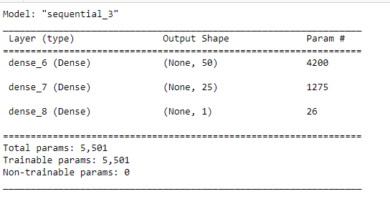

My final score proved an accuracy of over 75% with just over 50% loss.



As a result, the model accurately predicts 75% of approvals. The foundation can put faith in this model as it achieves the requirements in the brief. The results are promising and if I had to rework the program, I would review the inputs and possibly create a third layer of neurons, to see if that brought up my accuracy and brought down my loss number.